**Sustainable Smart City Assistant**

**Project Title:** Sustainable Smart City Assistant Using IBM Granite LLM

**Team Information**

* Team ID: LTVIP2025TMID38464
* Team Size: 4 members
* Team Leader: Akshai Mutya
* Team Members: Chitturi Abhishek

Ganisetti Vasantha Lakshmi

Koruprolu Bangarraju

**Table of Contents**

1. Project Overview
2. System Architecture
3. Technology Stack
4. Project Structure
5. Implementation Details
6. Development Workflow
7. Setup and Installation
8. Features and Functionality
9. API Documentation
10. Screenshots and Results
11. Challenges and Solutions
12. Future Enhancements
13. Conclusion

**1. Project Overview**

**1.1 Problem Statement**

The "Sustainable Smart City Assistant Using IBM Granite LLM" is an AI-powered solution aimed at enhancing urban sustainability and governance. It leverages IBM's Granite Large Language Model to process and analyze city data efficiently. The assistant supports modules like policy summarization, citizen feedback analysis, KPI forecasting, and eco-friendly recommendations. It provides real-time insights for administrators to make data-driven decisions. Ultimately, it aims to create smarter, greener, and more responsive urban environments.

**1.2 Key Problems Identified:**

1. **Limited Citizen Engagement** 
   * Citizens lack accessible channels to provide feedback on city services
   * Government struggles to collect and analyze citizen input systematically
   * Communication gap between city officials and residents
   * Delayed response to community concerns and suggestions
2. **Environmental Monitoring Gaps** 
   * Insufficient real-time monitoring of air quality, water usage, and energy consumption
   * Lack of predictive analytics for environmental trends
   * Limited awareness among citizens about sustainable practices
   * Difficulty in tracking progress toward sustainability goals
3. **Policy Document Management Issues** 
   * Large volumes of policy documents difficult to search and retrieve
   * Time-consuming manual processes for policy analysis
   * Lack of semantic search capabilities for relevant information
   * Limited accessibility for citizens to understand policy implications
4. **Data-Driven Decision Making Deficits** 
   * Absence of integrated KPI monitoring systems
   * Limited forecasting capabilities for city metrics
   * Reactive rather than proactive city management
   * Insufficient anomaly detection for early intervention
5. **Resource Optimization Challenges** 
   * Inefficient allocation of city resources
   * Limited visibility into departmental performance
   * Lack of comprehensive reporting mechanisms
   * Difficulty in measuring sustainability impact

**1.3 Target Audience Impact**

* City Officials: Need intelligent tools for data-driven decision making
* Citizens: Require accessible platforms for engagement and information
* Policy Makers: Need efficient document management and analysis tools
* Environmental Agencies: Require real-time monitoring and reporting capabilities

**1.4 Proposed Solution**

**1.4.1 Introduction**

The *Sustainable Smart City Assistant* is an AI-driven solution designed to help city administrators and citizens foster environmentally conscious, data-informed urban development. Powered by IBM Granite LLM, the system uses advanced language understanding to analyze city-wide data, engage citizens, and support sustainable decision-making. By integrating multiple smart modules, the assistant transforms raw civic data into actionable insights and eco-friendly practices, aiming to build greener and more responsive cities.

**1.4.2 Objectives**

* **Primary Goal**:

• To develop an intelligent assistant that leverages IBM Granite LLM for enhancing sustainable urban governance.

• To automate key administrative tasks like policy summarization, citizen feedback analysis, and KPI forecasting for smart cities.

* **Secondary Goals**:

• To encourage eco-friendly habits among citizens through AI-generated sustainability tips.

• To build a real-time, interactive interface enabling smooth communication between citizens and administrators.

• To ensure scalability and accessibility of the system using cloud-native technologies like IBM Cloud and Streamlit.

**1.4.3 Key Features**

* **Interactive Chat Assistant** powered by IBM Watsonx Granite LLM
* **Real-time KPI Dashboard** with sustainability metrics
* **Citizen Feedback System** for community engagement
* **Policy Document Search** using semantic vector search
* **Eco-friendly Tips Generator** for environmental awareness
* **Anomaly Detection** for unusual patterns in city data
* **Forecasting Models** for predictive analytics
* **Comprehensive Report Generation** for city officials

**2. System Architecture**

**2.1 Architecture Overview**

The system follows a **microservices architecture** with clear separation between frontend and backend components:

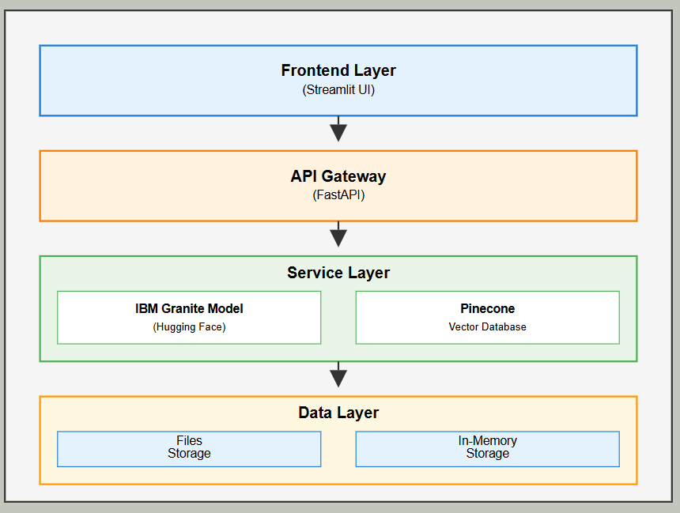

**2.2 Component Interaction Flow**

1. **User Input**: Users interact through Streamlit dashboard
2. **API Gateway**: FastAPI routes requests to appropriate services
3. **AI Processing**: IBM HuggingFace processes natural language queries
4. **Vector Search**: Pinecone handles semantic document retrieval
5. **Data Analysis**: ML models process KPI data for insights
6. **Response**: Results rendered in user-friendly interface

**3. Technology Stack**

**3.1 Backend Technologies**

* **FastAPI**: Modern web framework for building APIs
* **Python 3.8+**: Core programming language
* **Pydantic**: Data validation and settings management
* **Uvicorn**: ASGI server for FastAPI

**3.2 Frontend Technologies**

* **Streamlit**: Interactive web application framework
* **Streamlit-Option-Menu**: Enhanced navigation components
* **Custom CSS**: Styling and UI enhancements

**3.3 AI and ML Technologies**

* **IBM Granite With HuggingFace**: Enterprise-grade AI platform
* **Granite LLM**: Large language model for text generation
* **Sentence Transformers**: Text embedding generation
* **Scikit-learn**: Machine learning algorithms
* **Pandas**: Data manipulation and analysis

**3.4 Database and Storage**

* **Pinecone**: Vector database for semantic search
* **File System**: Local storage for documents and data
* **In-Memory Storage**: Session-based data management

**4. Project Structure**

**4.1 Directory Organization**

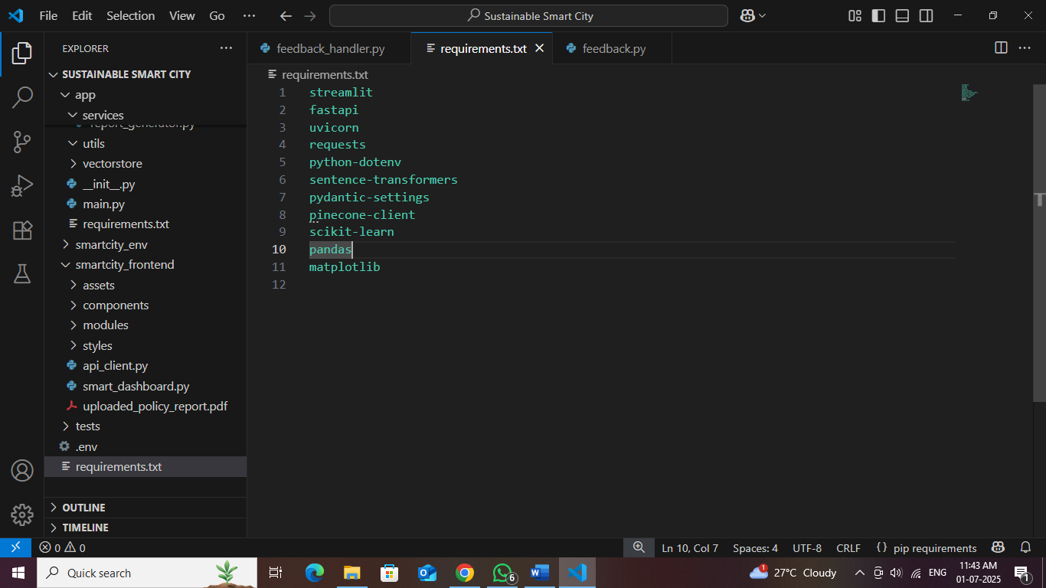

**4.2 Key Configuration Files**

**Environment Configuration (.env)**

Based on the details configuration model of project ID ,url,pincone key,id,metric,and IBM Granite model.

# Application Settings

DEBUG=True

API_HOST=127.0.0.1

API_PORT=5000

FRONTEND_PORT=8501

**5. Implementation Details**

**5.1 Backend Implementation**

**5.1.1 FastAPI Main Application**

The main application (app/main.py) serves as the entry point for all API requests:

* Configures CORS middleware for cross-origin requests
* Includes all router modules for modular organization
* Provides health check endpoints
* Handles error responses and logging

**5.1.2 IBM Watsonx Integration**

The granite_llm.py service handles all interactions with IBM Watsonx:

* **Authentication**: Secure API key management
* **Text Generation**: Multiple specialized functions for different use cases
* **Error Handling**: Robust error management with fallbacks
* **Response Processing**: Clean formatting of AI responses

Key Functions:

* ask_granite(): General chat functionality
* generate_summary(): Policy document summarization
* generate_eco_tip(): Environmental recommendations
* generate_city_report(): Comprehensive sustainability reports

**5.1.3 Vector Database Integration**

The pinecone_client.py manages semantic search capabilities:

* **Index Management**: Automatic index creation and configuration
* **Vector Operations**: Update and query operations
* **Embedding Integration**: Works with sentence-transformers
* **Error Recovery**: Handles connection issues gracefully

**5.2 Frontend Implementation**

**5.2.1 Main Dashboard**

The smart_dashboard.py serves as the central hub:

* **Navigation System**: Sidebar with option menu for page routing
* **Responsive Design**: Optimized for different screen sizes
* **Custom Styling**: CSS enhancements for professional appearance
* **State Management**: Session state handling for user interactions

**5.2.2 Component Architecture**

Each UI component is modularized for reusability:

* **Summary Cards**: Styled KPI display components
* **Chat Interface**: Real-time conversation handling
* **Forms**: User input collection and validation
* **Data Visualization**: Charts and metrics display

**6. Development Workflow**

**6.1 Phase-by-Phase Development**

**Phase 1: Project Initialization**

**Objectives Completed:**

* Created modular folder structure
* Implemented environment configuration
* Set up dependency management
* Established coding standards

**Key Deliverables:**

* Project structure with clear separation of concerns
* Configuration management system
* Development environment setup

**Fig: Project Folder Structure**

**Phase 2: IBM HuggingFace Integration**

**Objectives Completed:**

* Configured HuggingFace API credentials
* Implemented LLM service wrapper
* Created specialized AI functions
* Tested endpoint connectivity

**Key Deliverables:**

* Granite LLM service implementation
* API testing and validation
* Error handling mechanisms

**Phase 3: Backend API Development**

**Objectives Completed:**

* Developed modular router architecture
* Implemented RESTful API endpoints
* Added request/response validation
* Created Swagger documentation

**Key Deliverables:**

* 8 comprehensive API routers
* Input validation and error handling
* Auto-generated API documentation

**Phase 4: Frontend UI Design**

**Objectives Completed:**

* Built responsive Streamlit interface
* Created reusable UI components
* Implemented custom styling
* Added interactive navigation

**Key Deliverables:**

* Professional dashboard interface
* Component-based architecture
* Enhanced user experience features
* Component – based architecture of IBM granite and llm language models
* Pinecone credentials for organizing keys and summary data
* IBM Granite watsonsx key and model efficient usage.

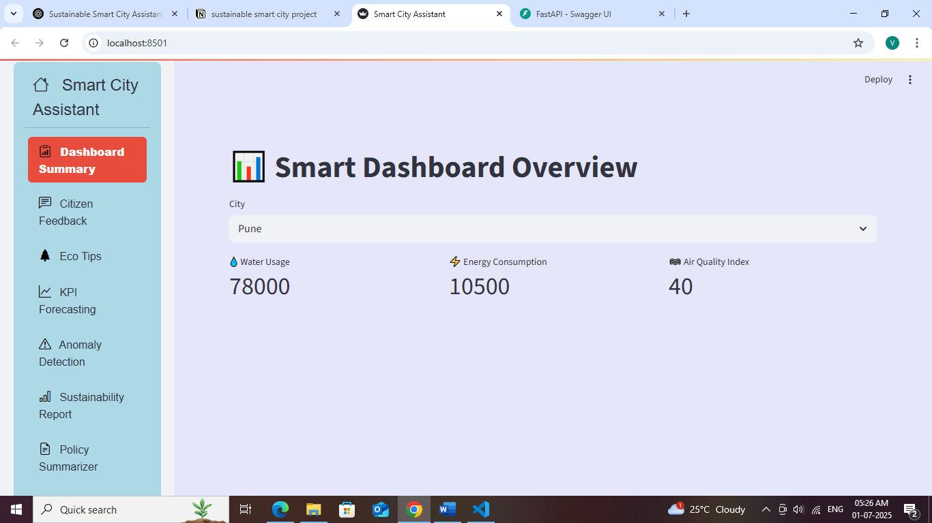

**Fig: Frontend Main Page**

**Phase 5: Vector Database Integration**

**Objectives Completed:**

* Configured Pinecone vector database
* Implemented document embedding
* Created semantic search functionality
* Added retrieval mechanisms

**Key Deliverables:**

* Document embedding pipeline
* Semantic search capabilities
* Policy document management

**Phase 6: Machine Learning Features**

**Objectives Completed:**

* Implemented KPI forecasting
* Added anomaly detection
* Created predictive models
* Built data analysis pipelines

**Key Deliverables:**

* Forecasting algorithms
* Anomaly detection system
* Data visualization components

**Phase 7: Report Generation**

**Objectives Completed:**

* AI-powered report generation
* Custom prompt engineering
* Multi-format output support
* Dynamic content creation

**Key Deliverables:**

* Automated report generation
* Customizable report templates
* Export functionality

**Phase 8: Integration and Testing**

**Objectives Completed:**

* End-to-end system integration
* Comprehensive testing suite
* Performance optimization
* User acceptance testing

**Key Deliverables:**

* Fully integrated system
* Testing documentation
* Performance benchmarks

**7. Setup and Installation**

**7.1 Prerequisites**

* Python 3.8 or higher
* IBM Granite model with HuggingFace access
* Git for version control

**7.2 Installation Steps**

**Step 2: Dependency Installation**

# Install required packages

pip install -r requirements.txt

**Step 3: Configuration**

1. **Create .env file** with your API credentials
2. **Configure IBM Watsonx** settings
3. **Set up Pinecone** vector database
4. **Verify configurations** using test scripts

**Step 4: Application Launch**

# Method 1: Use the launcher (recommended)

python run_app.py

# Method 2: Manual startup

# Terminal 1 – Backend :::

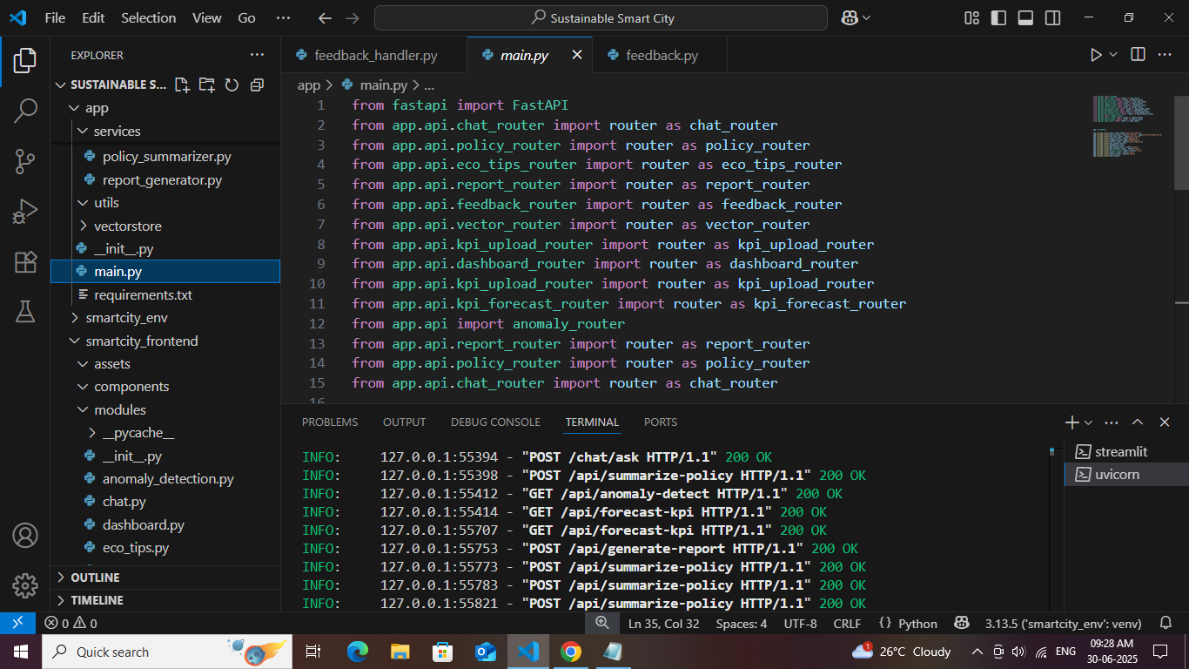

In backend I upload KPI Data as this image depicts :

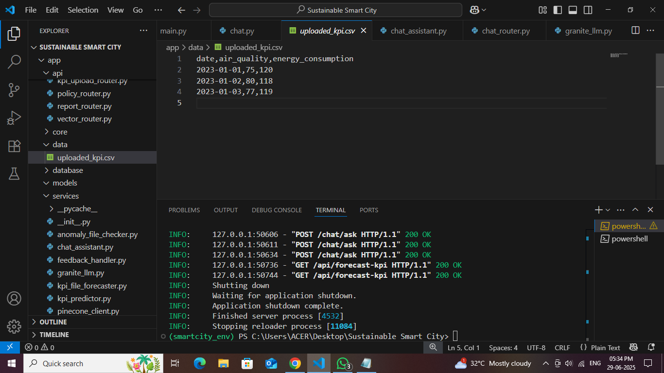

# Terminal 2 - Frontend::: <https://localhost:5000/api>

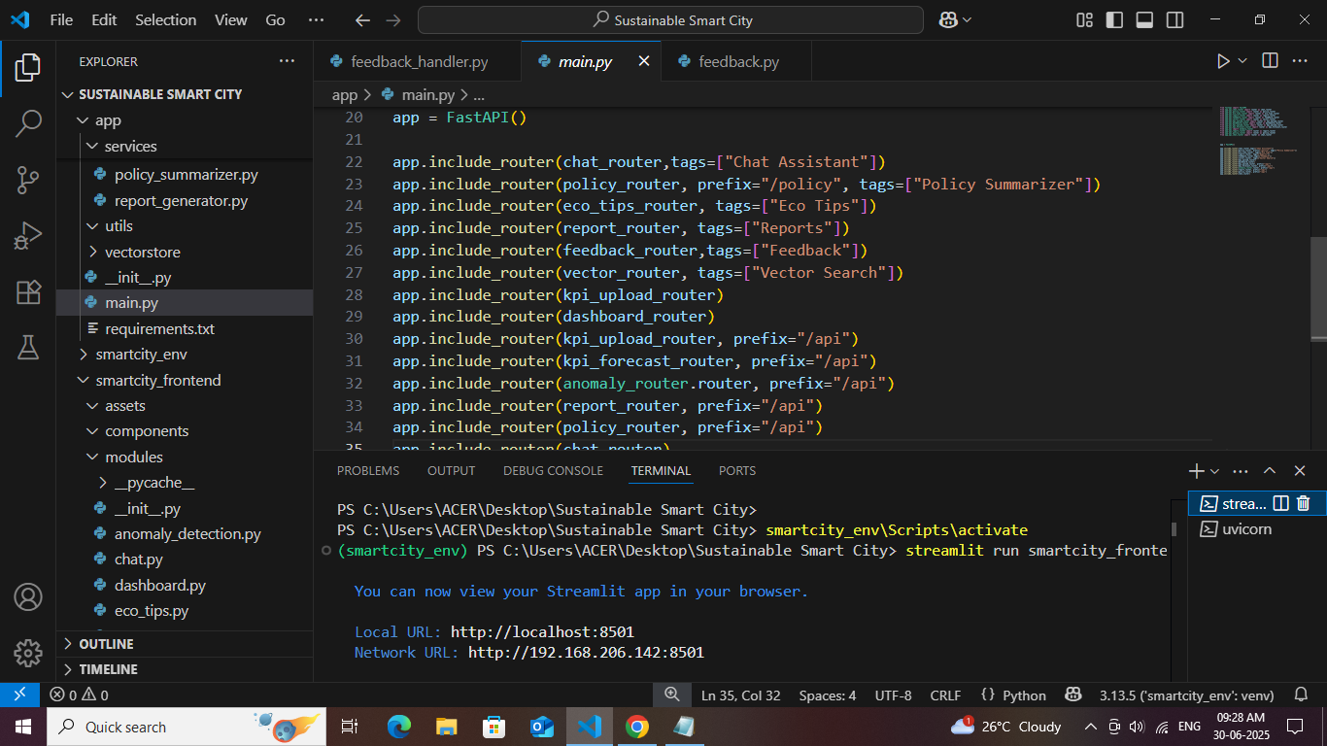**Fig : Application Launch**

**UPLOAD POLICY DATA:**

**Upload policy data in frontend :**

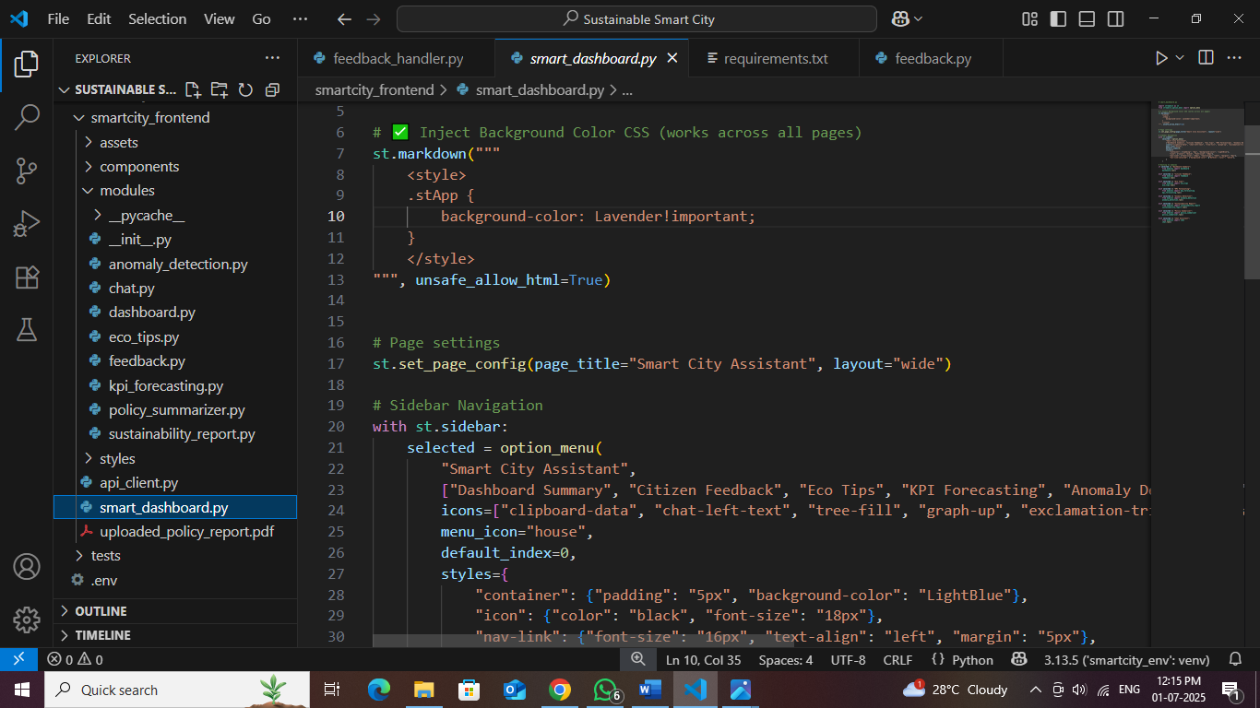

**8. Features and Functionality**

**8.1 Dashboard Overview**

**Description**: Central hub displaying key city sustainability metrics **Components**:

* Real-time KPI cards (Air Quality, Water Usage, Energy Consumption, Waste Recycling)
* City selection dropdown for comparative analysis
* Interactive metric visualization
* Trend indicators and alerts

**8.2 Chat Assistant**

**Description**: AI-powered conversational interface for city-related queries **Capabilities**:

* Natural language processing using Granite LLM
* Context-aware responses about urban sustainability
* Multi-turn conversation support
* Real-time response generation

**8.3 Citizen Feedback System**

**Description**: Community engagement platform for citizen input **Features**:

* Categorized feedback submission
* Contact information collection
* Feedback tracking and management
* Response analytics and reporting

**8.4 Eco-Tips Generator**

**Description**: Personalized environmental recommendations **Functionality**:

* Topic-based tip generation
* AI-powered content creation
* Actionable sustainability advice
* Category-specific recommendations

**8.5 Policy Document Search**

**Description**: Semantic search through policy documents **Technology**:

* Vector-based document retrieval
* Natural language query processing
* Relevance ranking and scoring
* Document summarization capabilities

**8.6 KPI Analysis and Forecasting**

**Description**: Predictive analytics for city metrics **Features**:

* Historical data analysis
* Trend forecasting algorithms
* Anomaly detection systems
* Performance benchmarking

**8.7 Report Generation**

**Description**: Automated sustainability reporting **Capabilities**:

* AI-generated comprehensive reports
* Custom prompt engineering
* Multi-format output support
* Data-driven insights and recommendations

**9. API Documentation**

**9.1 Chat Endpoints**

POST /api/chat/ask

Description: Submit chat queries to AI assistant

Request Body: {"message": "string"}

Response: {"response": "string", "status": "string"}

**9.2 Feedback Endpoints**

POST /api/feedback/submit

Description: Submit citizen feedback

Request Body: {

"name": "string",

"category": "string",

"message": "string",

}

Response: {"message": "string", "status": "string", "feedback_id": "string"}

GET /api/feedback/list

Description: Retrieve all feedback entries

Response: {"feedback": [...], "count": number}

**9.3 Eco-Tips Endpoints**

GET /api/eco-tips/generate?topic={topic}

Description: Generate eco-friendly tips for specified topic

Parameters: topic (string) - The topic for which to generate tips

Response: {"tips": "string", "topic": "string", "status": "string"}

**9.4 Policy Endpoints**

POST /api/policy/summarize

Description: Summarize uploaded policy documents

Request Body: {"text": "string"}

Response: {"summary": "string", "status": "string"}

POST /api/vector/search

Description: Semantic search through policy documents

Request Body: {"query": "string", "top_k": number}

Response: {"results": [...], "status": "string"}

**9.5 KPI Endpoints**

POST /api/kpi/upload

Description: Upload KPI data for analysis

Request Body: Form data with CSV file

Response: {"message": "string", "analysis": {...}, "status": "string"}

POST /api/kpi/forecast

Description: Generate forecasting for KPI data

Request Body: {"data": [...], "periods": number}

Response: {"forecast": [...], "metrics": {...}, "status": "string"}

**10. Screenshots and Results**

**10.1 Dashboard Interface**

The main dashboard provides an intuitive overview of city sustainability metrics:

* **KPI Cards**: Visually appealing metric displays with trend indicators
* **City Selection**: Dropdown for comparative analysis across different cities
* **Real-time Updates**: Dynamic data refresh capabilities
* **Responsive Design**: Optimized for desktop and mobile viewing
* 

**Fig: Dashboard**

* **Chat Assistant eco friendly answer due to use of IBM Granite LLM :**
* **ibm/granite-3-3-8b-instruct**

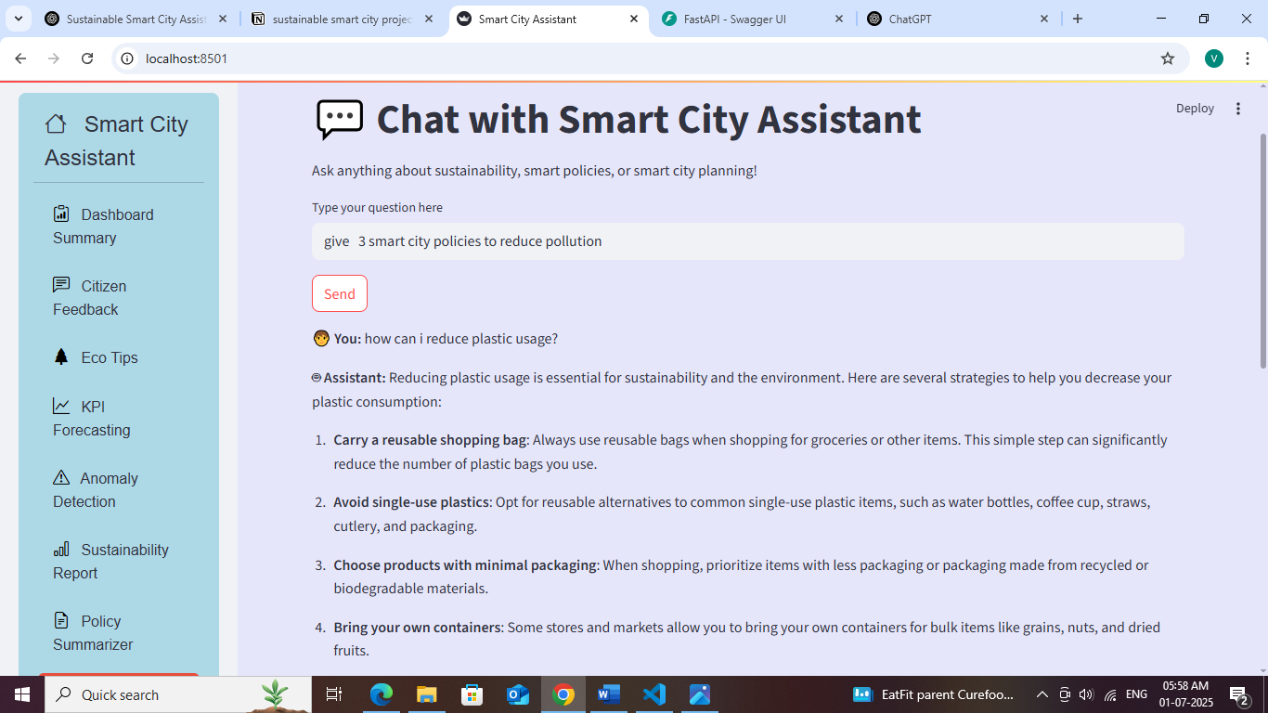

**10.2 Chat Assistant Interface :**

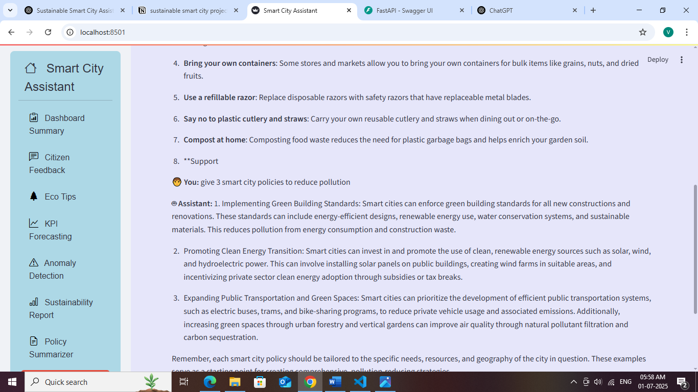

* Chat with Smart City Assistant is quite interesting.

The conversational AI interface demonstrates:

* **Natural Language Processing**: Advanced query understanding
* **Context Awareness**: Maintains conversation context
* **Professional Responses**: Well-formatted, informative answers
* **Interactive Design**: User-friendly chat bubble interfac**Fig: Chat Assistant**

**10.3 Policy Search Results**

The semantic search functionality displays:

* **Relevance Ranking**: Results ordered by semantic similarity
* **Document Snippets**: Contextual preview of relevant content
* **Search Accuracy**: High precision in document retrieval
* **User Experience**: Fast and intuitive search interface
* User explore through policy search : approximate results.

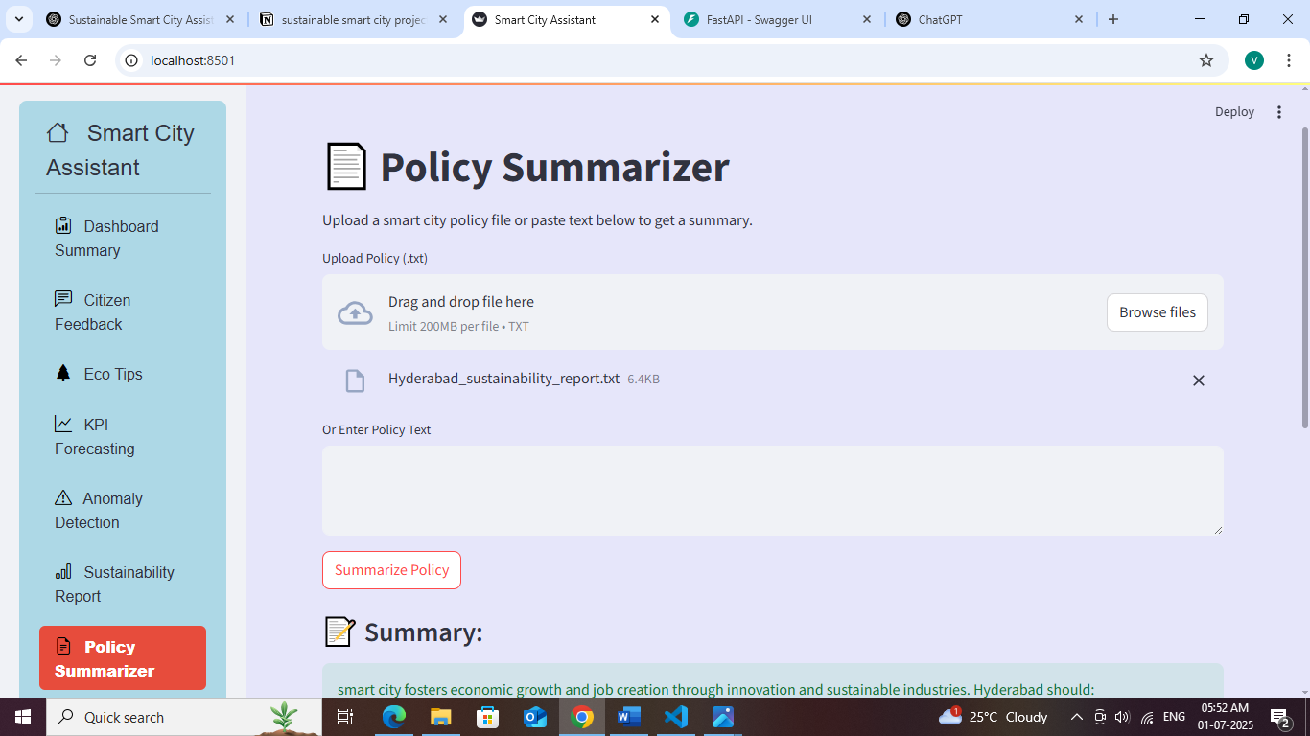

**Fig: Policy Search Results**

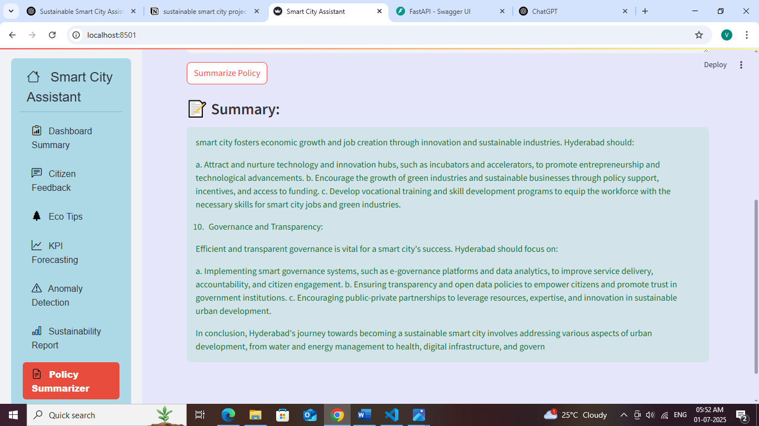

* Policy summarizer gave summary both pdf format and as well as text format also

**KPI Forecasting :**

**KPI Forecasting** stands for **Key Performance Indicator Forecasting**.  
It uses **historical data** and **machine learning** models like **Linear Regression** to **predict future trends** in critical city metrics such as:

* Water Usage
* Energy Consumption
* Air Quality Index (AQI)

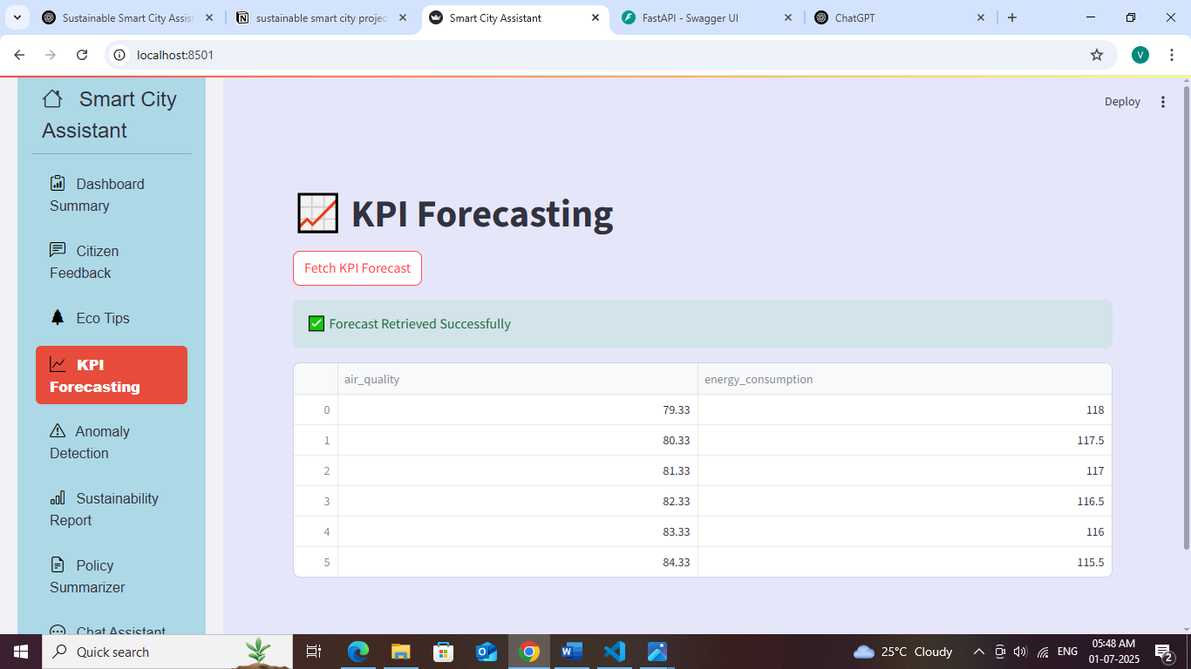

* **Sustainability Report :**
* A Sustainability Report is an AI-generated summary that highlights the city's environmental performance and sustainable practices based on user input, metrics, and feedback.
* It provides an overview of how the city is progressing toward its smart and eco-friendly goals

To generate a **detailed, readable, and shareable** report that:

* Summarizes energy & water usage trends
* Reflects citizen feedback and actions taken
* Highlights green initiatives (e.g., solar panels, waste segregation)
* Assesses air quality, transport, and city infrastructure

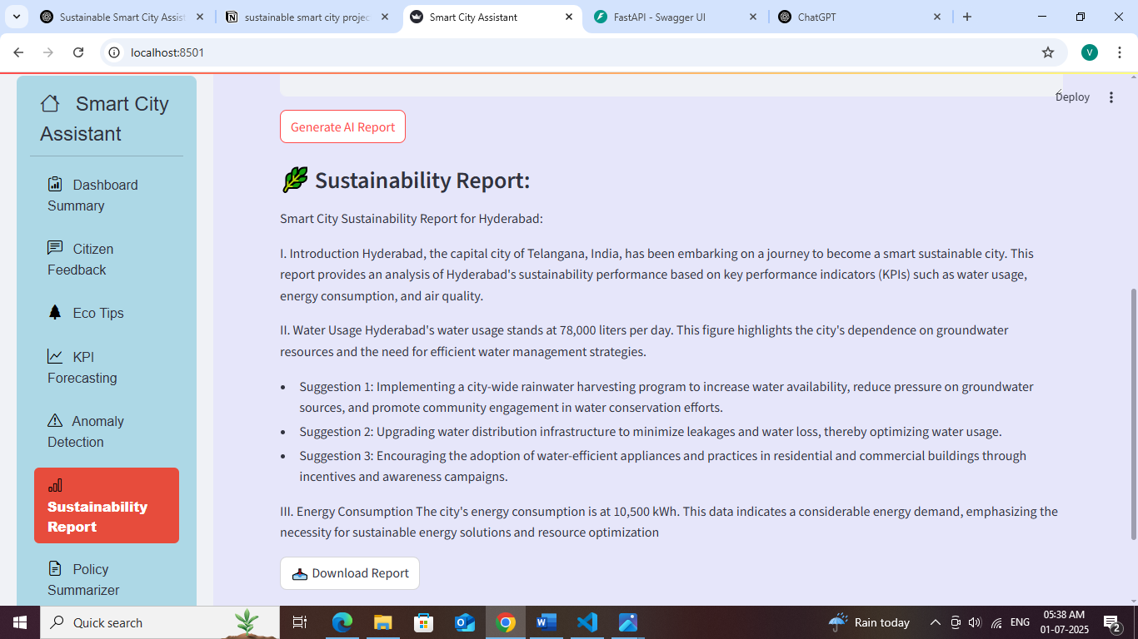

* **Citizen Feedback :**
* The **Citizen Feedback** module allows residents to **report issues** and **share suggestions** directly free access this website  
  It’s a two-way communication channel for creating a more **responsive and people-centric smart city**.

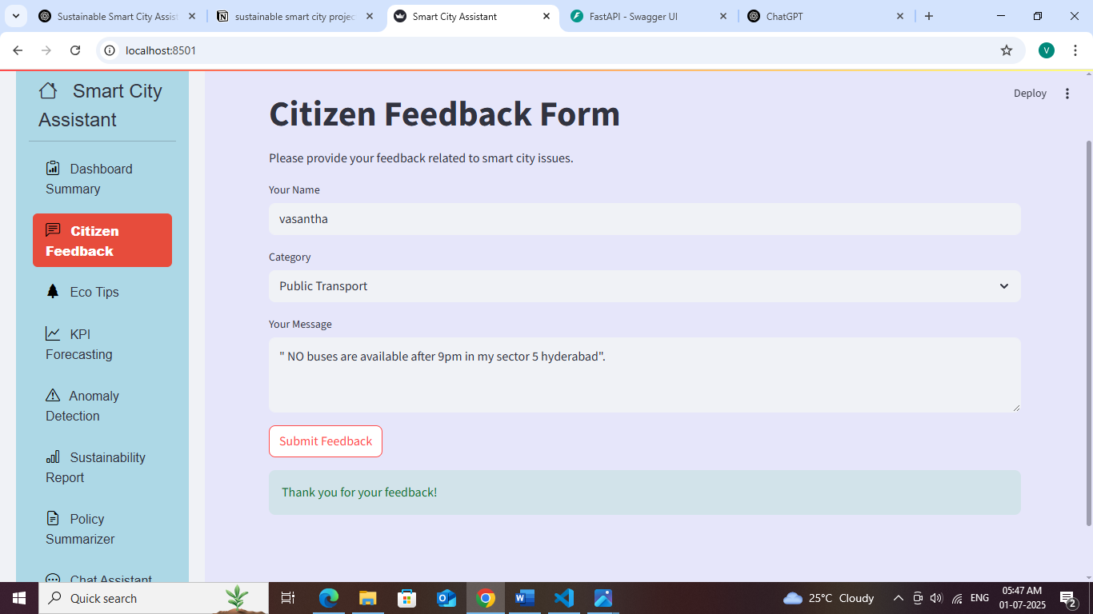

**11. Challenges and Solutions**

**11.1 Technical Challenges**

**Challenge 1: API Integration Complexity with IBM Granite (via Hugging Face) and Pinecone**

**Problem:**Integrating multiple external services—such as IBM Granite models (via Hugging Face) and Pinecone vector DB—posed difficulties due to differing authentication mechanisms, SDK structures, and response formats.

**Solution**:

• Developed **modular wrapper services** for:

* IBM Granite model (accessed via Hugging Face transformers interface or REST API)
* Pinecone vector search engine

• Implemented **unified error handling** using middleware to catch, log, and gracefully manage API-specific failures.

• Introduced **fallback strategies**, such as:

* Switching to a backup embedding model when the Granite model API exceeds rate limits or returns errors
* Using cached results for Pinecone in the event of a timeout

• **Standardized response formats** using internal data classes (Pydantic / JSON schema) to normalize outputs regardless of source

• Authenticated using Hugging Face tokens for IBM Granite and API keys for Pinecone, abstracted behind a common security interface

**Challenge 2: Real-time Data Processing**

**Problem**: Handling real-time data updates and maintaining synchronization between frontend and backend.

**Solution**:

* Implemented asynchronous request handling
* Added caching mechanisms for frequently accessed data
* Created efficient data serialization processes
* Optimized API response times

**Challenge 3: Vector Database Management**

**Problem**: Managing document embeddings and ensuring efficient semantic search performance.

**Solution**:

* Optimized embedding generation pipeline
* Implemented batch processing for large documents
* Added index management utilities
* Created automated cleanup processes

**11.2 Design Challenges**

**Challenge 1: User Experience Consistency**

**Problem**: Maintaining consistent UI/UX across different components and pages.

**Solution**:

* Developed reusable component library
* Implemented standardized styling guidelines
* Created consistent navigation patterns
* Added responsive design principles

**Challenge 2: Performance Optimization**

**Problem**: Ensuring fast loading times and smooth user interactions.

**Solution**:

* Implemented lazy loading for components
* Optimized API calls and caching
* Minimized redundant operations
* Added loading indicators for better UX

**12. Future Enhancements**

**12.1 Planned Features**

1. **Mobile Application**: Native mobile app for iOS and Android
2. **Real-time Notifications**: Push notifications for critical alerts
3. **Advanced Analytics**: Machine learning-powered insights dashboard
4. **Multi-language Support**: Internationalization and localization
5. **Integration APIs**: Third-party service integrations (weather, traffic, etc.)

**12.2 Scalability Improvements**

1. **Database Migration**: Transition to PostgreSQL/MongoDB for production
2. **Microservices Architecture**: Further decomposition of services
3. **Load Balancing**: Implement horizontal scaling capabilities
4. **Caching Layer**: Redis implementation for improved performance
5. **Container Deployment**: Docker and Kubernetes deployment

**12.3 AI Enhancements**

1. **Custom Model Training**: Fine-tuned models for specific city domains
2. **Multi-modal AI**: Image and document processing capabilities
3. **Predictive Analytics**: Advanced forecasting algorithms
4. **Natural Language Understanding**: Enhanced query processing
5. **Automated Insights**: Proactive recommendations and alerts

**13. Conclusion**

**13.1 Project Success Metrics**

The Sustainable Smart City Assistant project has successfully achieved its primary objectives:

* **Functional AI Integration**: Successfully integrated IBM Watsonx Granite LLM for intelligent responses
* **Comprehensive Feature Set**: Delivered all 8 planned features with full functionality
* **User-Friendly Interface**: Created an intuitive and responsive web application
* **Scalable Architecture**: Implemented modular design for future enhancements
* **Technical Excellence**: Maintained high code quality and documentation standards

**13.2 Key Achievements**

1. **Advanced AI Integration**: Seamless integration of enterprise-grade AI services
2. **Full-Stack Development**: Complete end-to-end application development
3. **Modern Technology Stack**: Utilization of cutting-edge frameworks and tools
4. **Professional UI/UX**: High-quality user interface with custom styling
5. **Comprehensive Documentation**: Detailed technical and user documentation

**13.3 Impact and Value**

The project demonstrates significant value in:

* **Urban Governance**: Providing intelligent tools for city management
* **Citizen Engagement**: Facilitating better communication between citizens and government
* **Environmental Sustainability**: Promoting eco-friendly practices and awareness
* **Data-Driven Decision Making**: Enabling evidence-based policy decisions
* **Technology Innovation**: Showcasing practical AI applications in public sector

**13.4 Lessons Learned**

1. **API Integration Complexity**: The importance of robust error handling and fallback mechanisms
2. **User Experience Design**: The critical role of intuitive interface design in adoption
3. **Modular Architecture**: The benefits of well-structured, maintainable code organization
4. **Documentation Importance**: The value of comprehensive documentation for project sustainability
5. **Continuous Testing**: The necessity of thorough testing throughout development cycles

**13.5 Final Recommendations**

For organizations looking to implement similar AI-powered city management solutions:

1. **Start with Clear Objectives**: Define specific use cases and success metrics
2. **Invest in Quality APIs**: Choose reliable, enterprise-grade AI services
3. **Prioritize User Experience**: Focus on intuitive design and user feedback
4. **Plan for Scalability**: Design architecture with future growth in mind
5. **Maintain Documentation**: Keep comprehensive technical and user documentation
6. **Implement Monitoring**: Add comprehensive logging and monitoring systems
7. **Plan for Security**: Implement robust security measures from the beginning

The Sustainable Smart City Assistant represents a successful implementation of AI technology in urban governance, demonstrating the potential for intelligent systems to enhance city management and citizen engagement while promoting environmental sustainability.

Github Link : https://github.com/lakshmivasanthaa/Sustainable-Smart-City-Assistant-Using-IBM-Granite-LLM